Control Flow (If-Else, Switch)

Theory Assignment
Question 1: What is control flow in JavaScript? Explain how if-else statements work with an example.
Ans: Control flow is the order in which the JavaScript interpreter executes statements in a script. By default, code runs from top to bottom, but control flow structures—like conditionals, loops, and functions—allow you to skip sections or repeat tasks based on specific conditions.

How If-Else Statements Work
The if...else statement is a primary decision-making tool in JavaScript. It directs the program to execute one block of code if a condition is true, and an alternative block if it is false.
- if block: The engine evaluates the condition inside parentheses. If it is "truthy," the code inside the curly braces {} executes.
- else block: This optional clause runs only if the if condition evaluates to "false".
- else if block: Used to check multiple distinct conditions sequentially.
Example: Checking Driving Eligibility
This example uses an if-else statement to determine if someone is old enough to drive based on their age.
Java script
let age = 16;

if (age >= 18) {
// Runs if age is 18 or higher
console.log("You are eligible for a driver's license.");
} else {
// Runs if the condition above is false (age is less than 18)
console.log("You are too young to drive.");
}
Visualizing the Flow
In this logic, the program reaches a "fork in the road". If the condition is met, it takes the first path; if not, it takes the second.
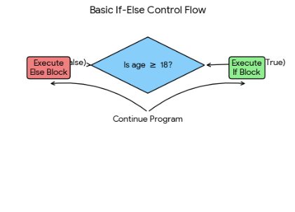

JavaScript if...else Statement
The if...else statement provides an alternate block of code to execute if the condition is false.
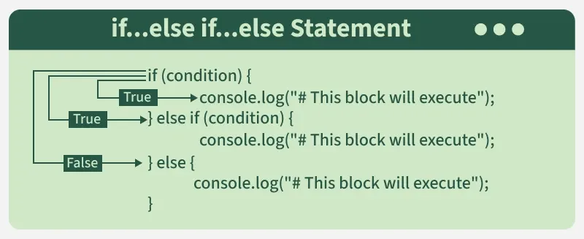
const temp = 25;
if (temp > 30) {
console.log("It's hot.");
} else if (temp >= 20) {
console.log("It's warm.");
} else {
console.log("It's cold.");
}
- Checks if the temperature is greater than 30, logs "It's hot."
- If not, checks if it's between 20 and 30, logs "It's warm."
- Otherwise, logs "It's cold."

Question 2: Describe how switch statements work in JavaScript. When should you use a switch statement instead of if-else?
Ans: In JavaScript, a switch statement evaluates an expression once and compares its result to multiple possible "case" values using strict equality (===). If a match is found, the associated block of code executes until it hits a break statement or the end of the switch block.
How it Works
- Expression Evaluation: The JavaScript switch statement on MDN Web Docs starts by evaluating a single expression.
- Case Matching: It checks the expression against each case value from top to bottom.
- Break Keyword: This is crucial. Without a break, the code "falls through" and executes all subsequent cases regardless of whether they match.
- Default Clause: An optional default block runs if no cases match the expression, acting as a fallback.
When to Use switch vs. if-else
Deciding between the two often comes down to readability and the nature of your conditions.
Feature | switch Statement | if-else Statement
Condition Type | Best for checking a single variable against multiple fixed values. | Best for complex logic, ranges (e.g., x > 10), or multiple different variables.
Readability | Cleaner for "multi-way branching" with many options (usually 5+). | Becomes messy and harder to maintain with long "else if" ladders.
Performance | Can be faster for many cases because engines often use Jump Tables for direct access. | Usually follows a linear search, evaluating every condition until a match is found.
Equality | Uses strict equality (===) only. | Can use any logical comparison (like ==, !=, <, >).
Recommendation: Use switch when you have a single variable that could be one of several specific values (like a day of the week or a command string). Use if-else for logical conditions, ranges, or when your branches depend on different variables
Syntax
switch (expression) {
case value1:
// Code block 1
break;
case value2:
// Code block 2
break;
// more cases
default:
// Default code block
}

How the Switch Statement Works
- Evaluation: The expression is evaluated once.
- Comparison: The value of the expression is compared against each case.
- Execution: The block under the matching case runs. If no match, the default block executes (if present).
- Break: Stops further execution within the switch block.
- Default: Runs if no cases match. It’s optional but provides a fallback option.
Flowchart of Switch Statement:

Now let's understand this with the help of example
let day = 3;
let day Name;
​
switch (day) {
case 1:
day Name = "Monday";
break;
case 2:
day Name = "Tuesday";
break;
case 3:
day Name = "Wednesday";
break;
case 4:
day Name = "Thursday";
break;
case 5:
day Name = "Friday";
break;
case 6:
day Name = "Saturday";
break;
case 7:
day Name = "Sunday";
break;
default:
day Name = "Invalid day";
}
​
console.log(day Name);
Output
Wednesday
In this example
- Day is set to 3.
- The switch statement evaluates day.
- Since day is 3, the case 3 the block is executed, assigning "Wednesday" to day Name.
- The break statement ends the switch statement, preventing execution from continuing into other case.

